

**Galerie Harold t’Kint de Roodenbeke**

The concept of the booth will present an immersion into the mobile world of the artist Pol Bury. A large part of the space will feature a reconstruction of the artist's studio through nearly 70 works; Mobile sculptures, static volumes, models, sculpture projects, paintings and cinetic drawings. The presented collection, directly coming from the Pol Bury Estate, will convey the whole diversity and creativity of this major artist from the kinetic movement. 

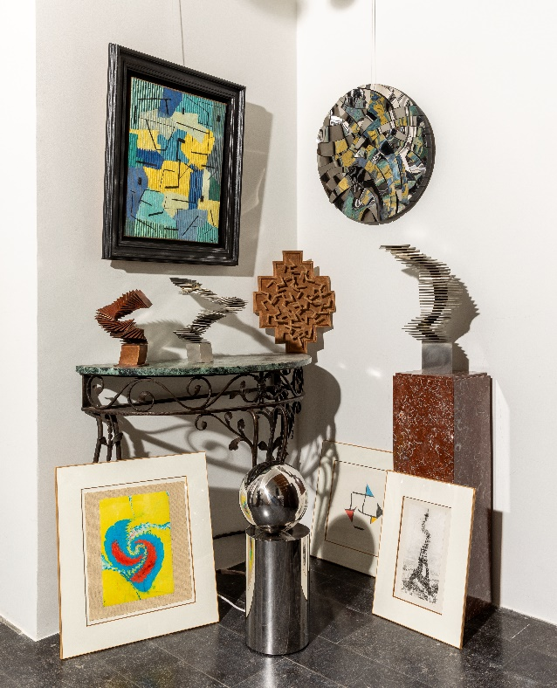

Le concept du stand proposera une immersion dans l'univers mobile de l'artiste Pol Bury.   
Une grande partie de l'espace mettra en scène une reconstitution de l'atelier de l'artiste à travers près de 70 oeuvres; sculptures mobiles, volumes figés, maquettes, projets de sculpture, peintures et dessins cinétiques. La collection présentée, provenant directement de l'estate de Pol Bury, montrera toute la diversité et la créativité de cet artiste majeur du mouvement cinétique.

Het standconcept biedt een immersie in het mobiele universum van kunstenaar Pol Bury.   
Een groot deel van de ruimte zal een reconstructie van het atelier van de kunstenaar bevatten aan de hand van bijna 70 werken; Mobiele sculpturen, statische volumes, modellen, sculptuurprojecten, schilderijen en kinetische tekeningen. De getoonde collectie, rechtstreeks afkomstig van het Pol Bury Estate, zal de diversiteit en creativiteit laten zien van deze belangrijke kunstenaar van de kinetische beweging.

Born in 1922 in Haine Saint-Pierre in Belgium, Pol Bury studied at the Academy of Beaux-Arts in Mons from 1938, and between 1940 and 1953, he started his career as a painter. Interested a short time in the surrealist movement, he notably participated as an illustrator in the surrealist review *L’invention collective* created by Magritte and Ubac in 1940. In 1945, he becomes one of the founders of the *Haute Nuit* group with Achille Chavée, which specialised in publishing, and took part in the COBRA’ movement in 1949. He created the Montbéliard Academy with André Balthasar in 1954.

Having discovered Calder’s works, he abandoned painting for the sculpture and exhibited for the first time his *Plans Mobiles*. Influenced by cinetism, he created panels which appearance depends on the position of the visitor. In 1957 his first animated works appeared, called *Multi-plans*. He then used various elements such as lighting effects, balls or still disks. Bury began his important series of opened and closed sculptures in 1963.

​

At the beginning of the 1960s, he started working with flat surfaces again and created his famous *Cinétisations*, photographs which he had taken or bought and then cut up. He was mainly interested in New York, Chicago and Paris. Moreover, he said in the Pol Bury catalogue by André Balthazar published by Cosmos in 1976 « *the verticality of New York skyscrapers lend themselves perfectly to the process of cinétisation*.».

In 1968, he returned to sculptures and works based on the notion of attraction and repulsion, therefore metal became the material he used the most frequently. Bury also created jewelry as well as monumental works, mainly fountains, for various institutions and places such as the Guggenheim Museum in New York or even the Palais-Royal gardens in Paris.

​

**Galerie Harold t’Kint de Roodenbeke – STAND 32**

Rue Ernest Allard 31

1000 Brussels

m. +32 (0)475 34 01 11

h.k@skynet.be | www.haroldtkint.com